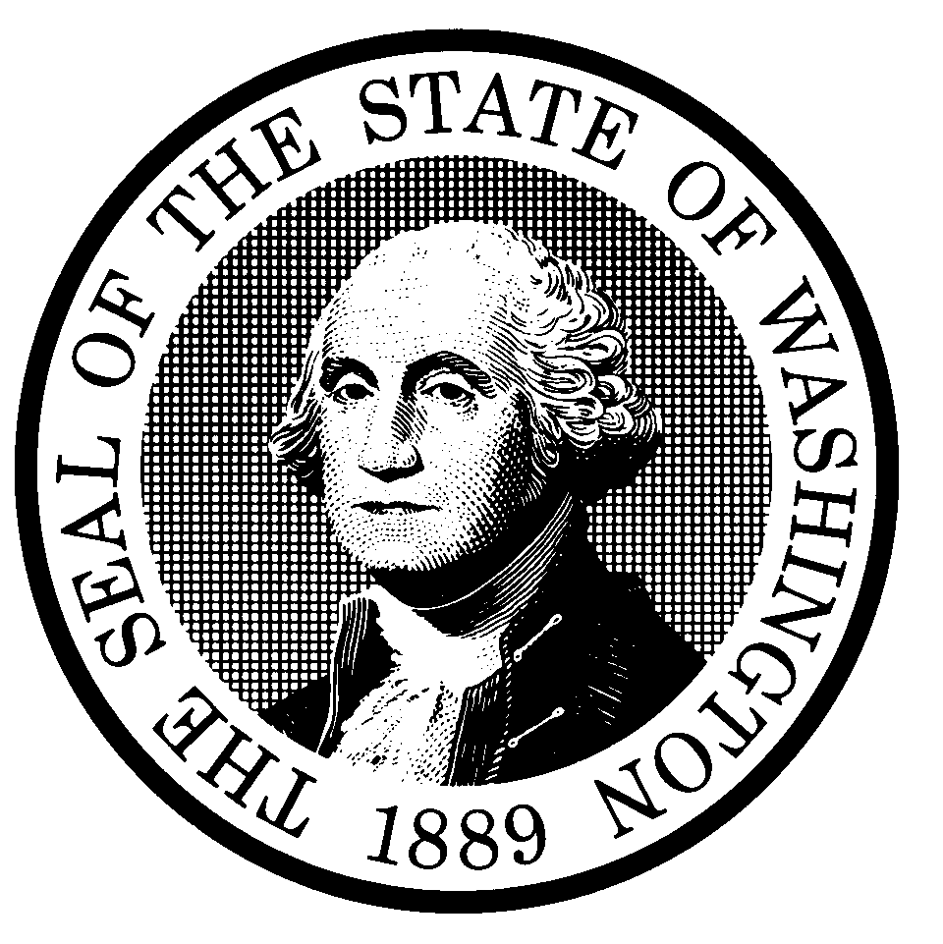

**STATE OF WASHINGTON**

**STATE BUILDING CODE COUNCIL**

**15-014**

# State Building Code to be Amended:

International Building Code State Energy Code

ICC ANSI A117.1 Accessibility Code International Mechanical Code International Existing Building Code International Fuel Gas Code International Residential Code NFPA 54 National Fuel Gas Code

International Fire Code NFPA 58 Liquefied Petroleum Gas Code

Uniform Plumbing Code Wildland Urban Interface Code

# Section(s): 1105.1 Page: 209 Title: General

1. **Proponent Name (Specific local government, organization or individual): Proponent: Department of Health: Construction Review Services Title:**

**Date: 2/2015**

1. **Designated Contact Person: Name: Matthew Campbell Title: Senior Plans Reviewer**

**Address: 111 Israel Rd. Tumwater WA 98501**

**Office Phone: 360-236-2944 Cell:**

**E-Mail address:** [**matthew.campbell@doh.wa.gov**](mailto:matthew.campbell@doh.wa.gov)

February 20, 2015

# Proposed Code Amendment.

**Code(s)** IFC **Section(s) 1105.1** Page 209

1. **General.** Existing Group I-2 shall meet all of the following requirements:
   1. The minimum fire safety requirements in Section 1103.
   2. The minimum means of egress requirements in Section 1104.
   3. The additional egress and construction requirements Section 1105.

Where the provisions of this chapter conflict with the construction requirements that applied at the time of construction, the most restrictive provisions shall apply.

# Amend section to read as follows:

1. **General.** This section shall be applied by jurisdictions conducting survey for compliance with the federal Centers for Medicare and Medicare reimbursement program.

Existing Group I-2 shall meet all of the following requirements:

* 1. The minimum fire safety requirements in Section 1103.
  2. The minimum means of egress requirements in Section 1104.
  3. The additional egress and construction requirements Section 1105.

Where the provisions of this chapter conflict with the construction requirements that applied at the time of construction, the most restrictive provisions shall apply.

# Briefly explain your proposed amendment, including the purpose, benefits and problems addressed.

Section 1105 is new to the 2015 Fire Code and provides retroactive minimum standards for hospitals. This content essentially matches the federal requirements used by the Washington State Office of the State Marshal for survey of existing licensed hospitals. Use of this chapter by local authorities having jurisdiction would create the opportunity, by way of interpretation, for a local AHJ to provide direction contrary to the OSFM. Differing interpretations would be at best confusing, and at worse conflicting and potentially place the facility out of compliance with federal requirements for reimbursement. As this section is retroactive and has the potential to require retrofit or modifications to existing approved construction the need for careful and accurate application of these rules is essential.

Hospitals exist in a highly regulated environment. Their associations and advocacy groups quickly and appropriately identify where inconsistency exists among regulatory authorities. Inconsistencies in retroactive requirements are unfair, and will be sure to be noticed by the industry.

The long term goal of Section 1105 is to provide federal agencies an alternative to the NFPA 101 Life Safety Code. To date, the federal authorizes that adopt NFPA 101 for healthcare facilities have not moved to the ICC Fire Code. Without amendment, this places hospitals and enforcement agents in a potentially difficult place.

We believe the concepts in this section are already being adequately applied through the Washington States hospital regulation to the current federal standards. The proposed scoping language supports established State processes with minimal code amendment.

1. **Specify what criteria this proposal meets.** You may select more than one.

The amendment is needed to address a critical life/safety need.

The amendment is needed to address a specific state policy or statute.

The amendment is needed for consistency with state or federal regulations. The amendment is needed to address a unique character of the state.

The amendment corrects errors and omissions.

1. **Is there an economic impact:** Yes No Explain:

If there is an economic impact, use the Table below to estimate the costs and savings of the proposal on construction practices, users and/or the public, the enforcement community, and operation and maintenance. If preferred, you may submit an alternate cost benefit analysis.

|  |  |  |  |  |  |  |
| --- | --- | --- | --- | --- | --- | --- |
| Building Type | Construction1 | | Enforcement2 | | Operations & Maintenance3 | |
| Costs | Benefits4 | Costs | Benefits4 | Costs | Benefits4 |
| Residential |  |  |  |  |  |  |
| Single family |  |  |  |  |  |  |
| Multi-family |  |  |  |  |  |  |
| Commercial/Retail |  |  |  |  |  |  |
| Industrial |  |  |  |  |  |  |
| Institutional |  |  |  |  |  |  |

Please send your completed proposal to: [sbcc@ga.wa.gov](mailto:sbcc@ga.wa.gov)

All questions must be answered to be considered complete. Incomplete proposals will not be accepted.

1 $ / square foot of floor area or other cost. Attach data. **Construction** costs are costs prior to occupancy, and include both design and direct construction costs that impact the total cost of the construction to the owner/consumer.

2 Cost per project plan. Attach data. **Enforcement** costs include governmental review of plans, field inspection, and other action required for enforcement.

3 Cost to building owner/tenants over the life of the project.

4 Measurable benefit.