Chapter 202

AUTOMATIC LOAD MANAGEMENT SYSTEM (ALMS). A system designed to manage electrical load across one or more EV charging stations and EV Ready parking spaces.
ELECTRIC VEHICLE (EV) CAPABLE PARKING SPACE. A parking space provided with a conduit, electrical panel and load capacity to support future installation of EV charging equipment.
ELECTRIC VEHICLE (EV) CHARGER. Off-board charging equipment used to charge electric vehicles.
ELECTRIC VEHICLE (EV) CHARGING STATION. EV Ready parking space with installed EV charger.
ELECTRIC VEHICLE (EV) READY PARKING SPACE. A parking space provided with a receptacle outlet allowing charging of electric vehicles.
ELECTRIC VEHICLE SUPPLY EQUIPMENT (EVSE). The conductors, including the ungrounded, grounded, and equipment grounding conductors, and the electric vehicle connectors, attachment plugs, personnel protection system, and all other fittings, devices, power outlets, or apparatus installed specifically for the purpose of transferring energy between the premises wiring and the electric vehicle.

Section 429—Electric vehicle charging infrastructure.
429.1 General. The provisions of this section shall apply to the construction of new buildings and accessory structures, including parking lots and parking garages.
Electric vehicle supply equipment (EVSE) shall be installed in accordance with applicable requirements of chapter 19.28 RCW and the National Electrical Code, Article 625.
EXCEPTION: Electric vehicle charging infrastructure is not required if any of the following conditions are met:
- There is no public utility or commercial power supply.
- Dwelling units without garages or other on-site parking.
429.2 Electric vehicle (EV) charging infrastructure. Buildings and accessory structures shall be provided with EV charging stations, EV-Ready parking spaces, and EV-capable parking spaces in accordance with Table 429.2. Calculations shall be rounded up to the nearest whole number. Where a building contains more than one occupancy, the electric vehicle charging infrastructure percentages of Table 429.2 shall be applied to the number of spaces required for each occupancy.
EXCEPTIONS: 1. Except for Group A, Group E, and Group M occupancies, on-site parking with less than 10 parking spaces shall not be required to comply with Section 429.2.
2. Group A, Group E, and Group M occupancies shall comply with one of the following, whichever is greater:
2.1. The provisions of Section 429.2 shall apply only to designated employee parking spaces.
2.2. One of each 200 parking spaces or fraction thereof shall be EV Ready. One of each 200 parking spaces or fraction thereof shall be an EV Charging Station.
Table 429.2
Electric Vehicle Charging Infrastructure
Occupancy |  | Number of EV  Charging Stations | Number of EV-Ready Parking Spaces | Number of EV-Capable Parking Spaces
Group A, B, E, F, H, I, M, and S occupancies |  | 10% of total parking spaces | 10% of total parking spaces | 10% of total parking spaces
Group R occupancies
 | Buildings that do not contain more than two dwelling units | Not required | One for each dwelling unit | Not required
 | Dwelling units with private garages | Not required | One for each dwelling unit | Not required
All other Group R occupancies |  | 10% of total parking spaces | 10%25% of total parking spaces | 40%10% of total parking spaces
429.2.1 EV charging stations and EV-Ready parking spaces. A minimum of 40-ampere dedicated 208/240-volt branch circuit shall be installed for each EV Ready parking space and each EV Charging Station. The branch circuits shall terminate at a receptacle outlet or EV charger in close proximity to the proposed location of the EV Ready parking space or the EV Charging Station.
429.2.2 EV-Capable parking spaces. A listed raceway capable of accommodating a minimum of 40-ampere dedicated 208/240-volt branch circuit shall be installed for each EV-Capable parking space. A continuous raceway shall be installed between an enclosure, end cap, or outlet located within close proximity of the electric vehicle (EV) capable parking space and future or existing panelboard or switchboard location(s).The raceway shall terminate into a cabinet, box or other enclosure in close proximity to the proposed location of the EV-Capable parking space. Raceways and related components that are planned to be installed underground, and in enclosed, inaccessible or concealed areas and spaces, shall be installed at the time of original construction.
429.3 Electrical room(s) and equipment. Electrical room(s) and/or areas for dedicated electrical equipment shall be sized to accommodate the requirements of Section 429.2.1 through 429.2.2.
The electrical service and the electrical system, including any on-site distribution transformer(s), shall have sufficient capacity to simultaneously charge all EVs at all required EV Charging Stations, and EV Ready parking spaces, and EV-Capable parking spaces at a minimum of 40-amperes each.
EXCEPTION: Automatic Load Management System (ALMS) may be used to adjust the maximum electrical capacity required for the EV Charging stations and EV-Ready and EV-Capable parking spaces. The ALMS must be designed to allocate charging capacity among multiple future EV Charging Stations at a minimum of 16 amperes per EV charger.
429.4 Electric vehicle charging infrastructure for accessible parking spaces. Ten percent of the accessible parking spaces, rounded to the next whole number, shall be EV Charging Stations. Additional 10 percent of the accessible parking spaces, rounded to the next whole number, shall be EV Ready. Not fewer than one for each type of EV charging system shall be accessible.
The electric vehicle charging infrastructure may also serve adjacent parking spaces not designated as accessible parking. A maximum of 10 percent of the accessible parking spaces, rounded to the next whole number, are allowed to be included in the total number of electric vehicle parking spaces required under Section 429.2.

Section 1106—Parking and passenger loading facilities.
1106.7 Location. Accessible parking spaces shall be located on the shortest accessible route of travel from adjacent parking to an accessible building entrance. In parking facilities that do not serve a particular building, accessible parking spaces shall be located on the shortest route to an accessible pedestrian entrance to the parking facility. Where buildings have multiple accessible entrances with adjacent parking, accessible parking spaces shall be dispersed and located near the accessible entrances. Wherever practical, the accessible route shall not cross lanes of vehicular traffic. Where crossing traffic lanes is necessary, the route shall be designated and marked as a crosswalk.
EXCEPTION: 1. In multilevel parking structures, van accessible parking spaces are permitted on one level.
2. Accessible parking spaces shall be permitted to be located in different parking facilities if substantially equivalent or greater accessibility is provided in terms of distance from an accessible entrance or entrances, parking fee and user convenience.

This revision references the NWPCC Power Plan data to align the current and 'anticipated' levels of EV stock. With this approach, Table 429.2 has a specific reference that gets updated every 5 years to align immediate (5% current, set by statute at minimum of 10%), near-term (current code cycle = 5 year = 19.4% = 10+10%), and long-term (20 year = 57.1% = 10+10+40%).
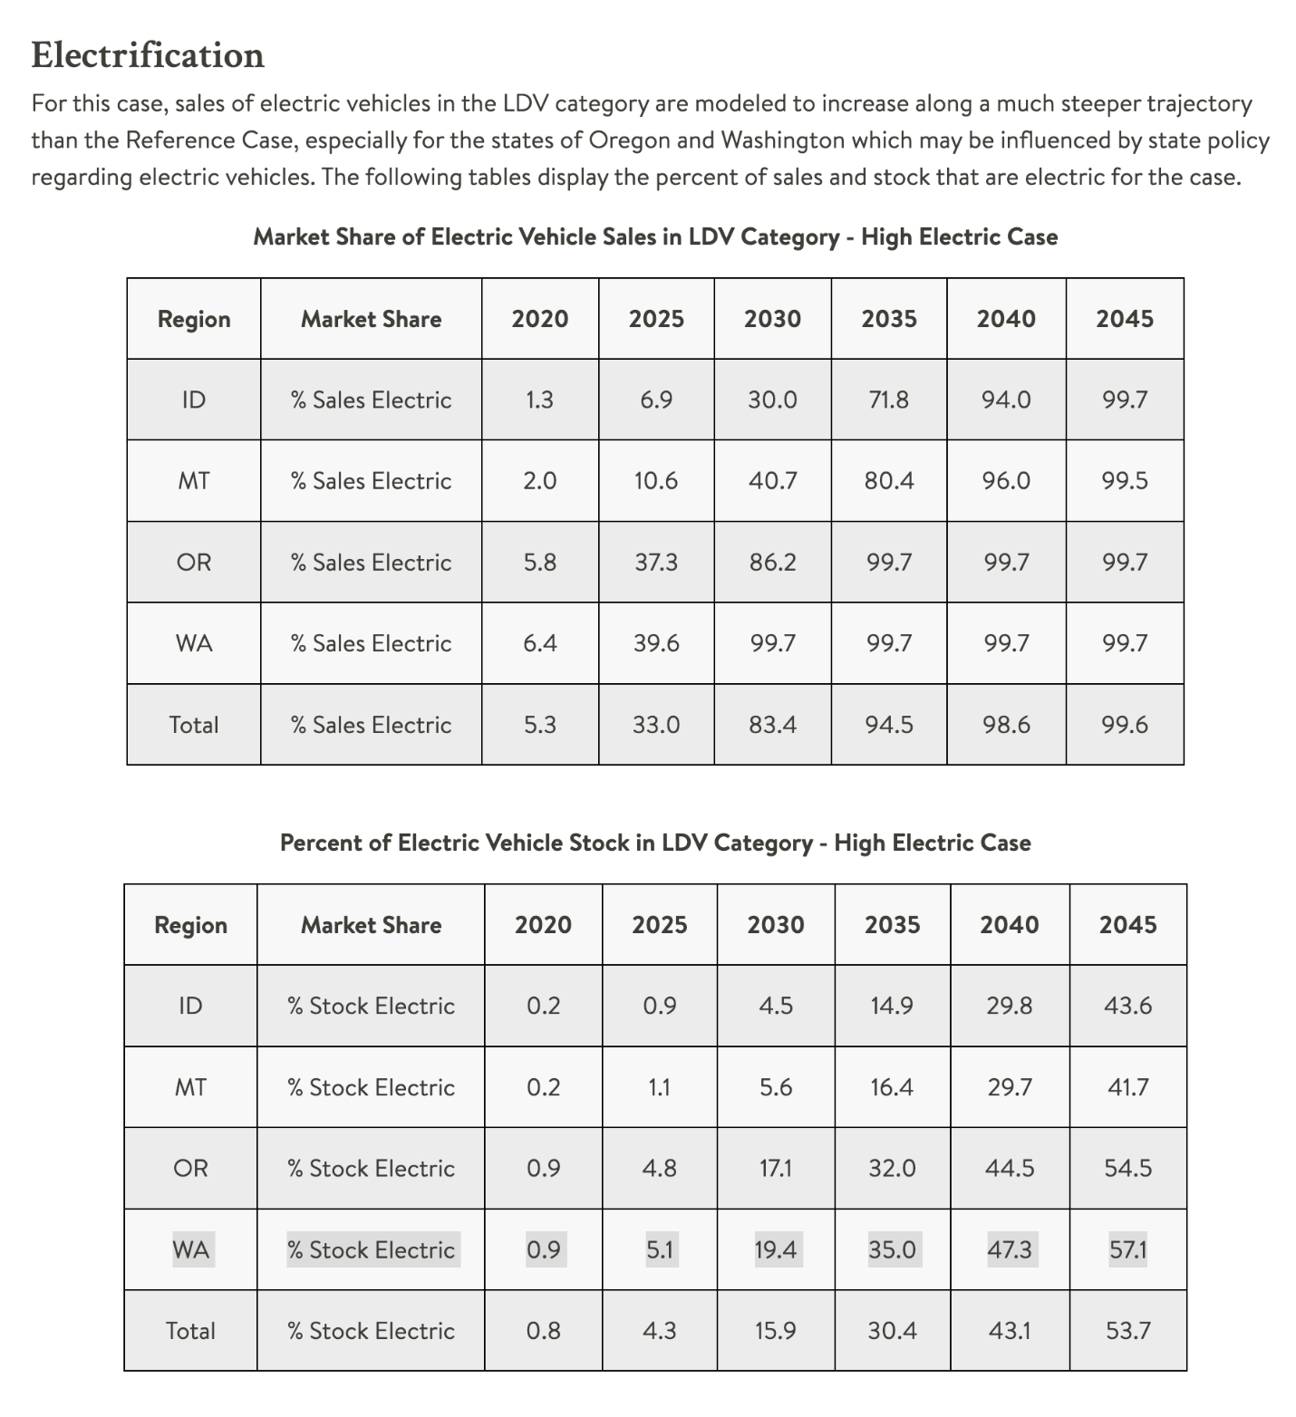
10% EVSE-installed + 10% EV-ready = 20% also exceeds the RCW 19.27.540 requirements for electrical room size. EV-capable parking spaces are considered in the required electrical room size, but not installed electrical service and electrical system requirements.
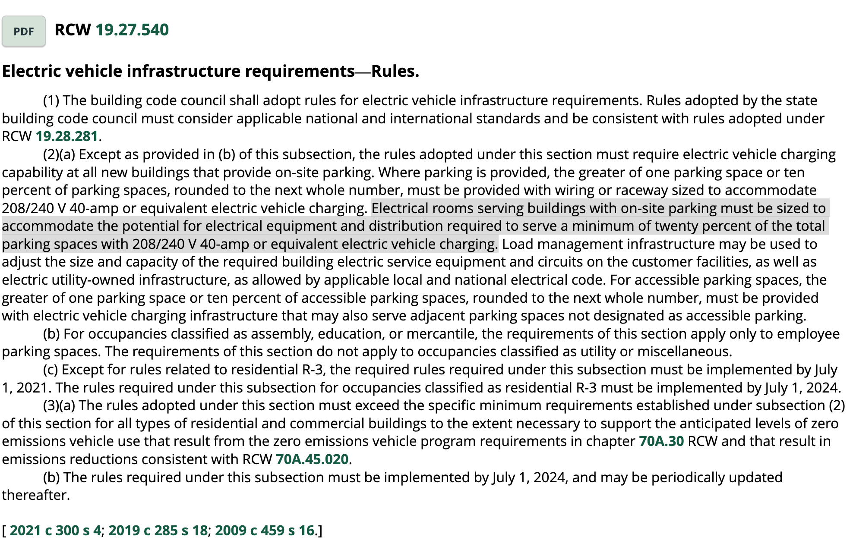

These amendments argue a 2025 / 2030 / 2045 mix for EV / EV-ready / EV-capable of:
10% / 10% / 40% from current 10% / 25% / 10%.

The sensitivity chart below visualizes the base case vs. proposed case (EV-required vs. EV-ready vs. EV-capable). Actual costs can be applied to this simple model for first-cost comparisons.
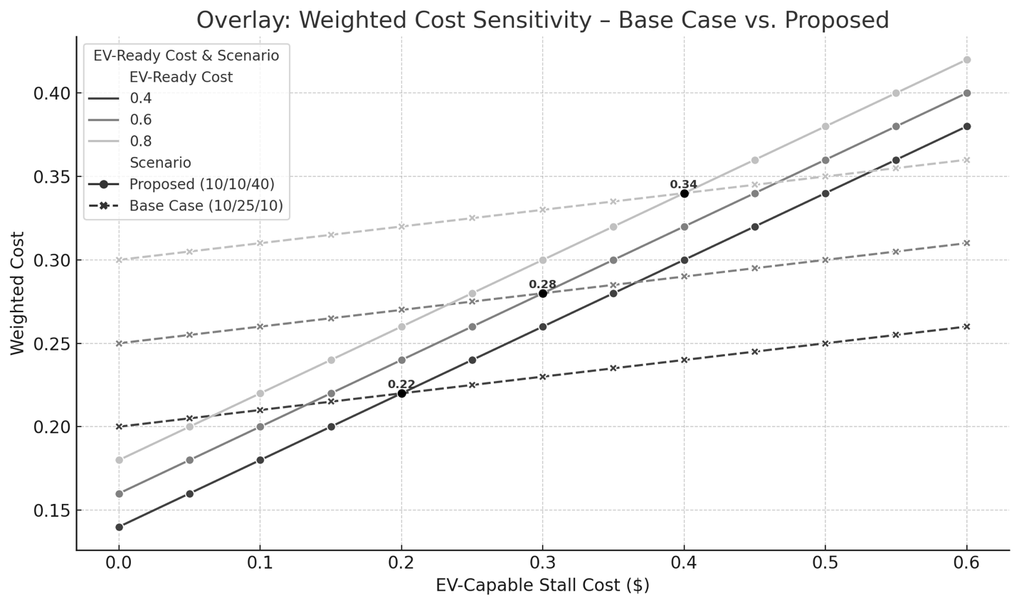
For example:
EV-required = $1.00 cost (normalized)
EV-ready = $0.80, $0.60, or $0.40 cost (relative)
EV-capable = $0.00 to $0.60 cost (relative)

The intersections are the 'break even' costs to the existing base case (10/25/10). Real cost data should be requested from developers to populate the model.

