[red] indicates R3 revisions 2025 07 12

Chapter 202
IBC: AUTOMOBILE PARKING SPACE. A space within a building or private or public parking lot, exclusive of driveways, ramps, columns, office and work areas, for the parking of an automobile.
NEC: Not Included
Rationale: aligns with definition in 2024 IECC Appendix RE (Electric Vehicle Charging Infrastructure).
IBC: AUTOMATIC LOAD MANAGEMENT SYSTEM (ALMS). A system designed to manage electrical load across one or more EV charging stations and EV Ready parking spaces EVSE spaces.
NEC: Not Included

IBC: ELECTRIC VEHICLE (EV). An automotive-type vehicle for on-road use, such as passenger automobiles, buses, trucks, vans, neighborhood electric vehicles and electric motorcycles, primarily powered by an electric motor that draws current from a building electrical service, electric vehicle supply equipment (EVSE), a rechargeable storage battery, a fuel cell, a photovoltaic array, or another source of electric current.
NEC: Electric Vehicle (EV). An automotive-type vehicle for on-road use, such as passenger automobiles, buses, trucks, vans, neighborhood electric vehicles, and electric motorcycles, primarily powered by an electric motor that draws current from a rechargeable storage battery, fuel cell, photovoltaic array, or other source of electric current. Plug-in hybrid electric vehicles (PHEV) are electric vehicles having a second source of motive power. (CMP-12)
Informational Note: Off-road, self-propelled electric mobile machines, such as industrial trucks, hoists, lifts, transports, golf carts, airline ground support equipment,

Rationale: aligns with definition in 2024 IECC Appendix RE (Electric Vehicle Charging Infrastructure).
IBC: ELECTRIC VEHICLE (EV) CAPABLE PARKING SPACE (EV CAPABLE SPACE). A designated automobile parking space parking space that is provided with a raceway and electrical distribution equipment space conduit, electrical panel and load capacity to support necessary for the future installation of an EVSE EV charging equipment.
NEC: Not Included

Rationale: aligns with definition in 2024 IECC Appendix RE (Electric Vehicle Charging Infrastructure).
ELECTRIC VEHICLE (EV) CHARGER. Off-board charging equipment used to charge electric vehicles.
Rationale: replaced by EVSE definition.
ELECTRIC VEHICLE (EV) CHARGING STATION. EV Ready parking space with installed EV charger.
Rationale: replaced by EVSE space definition.
IBC: ELECTRIC VEHICLE (EV) READY PARKING SPACE (EV READY SPACE). An automobile parking space parking space that is provided with a receptacle outlet allowing charging of electric vehicles a branch circuit and an outlet, junction box, or receptacle that will support an installed EVSE.
NEC: Not Included

Rationale: aligns with definition in 2024 IECC Appendix RE (Electric Vehicle Charging Infrastructure).
IBC: ELECTRIC VEHICLE SUPPLY EQUIPMENT (EVSE). Equipment for plug-in power transfer The conductors, including the ungrounded, grounded, and equipment grounding conductors, and the; electric vehicle connectors,; attachment plugs,; any personal personnel protection system,; and all other fittings, devices, power outlets, or apparatus installed specifically for the purpose of transferring energy between the premises wiring and the electric vehicle electric vehicle.
NEC: Electric Vehicle Supply Equipment (EVSE). Equipment for plug-in charging, including the ungrounded, grounded, and equipment grounding conductors, and the electric vehicle connectors, attachment plugs, personnel protection system, and all other fittings, devices, power outlets, or apparatus installed specifically for the purpose of transferring energy between the premises wiring and the electric vehicle.
Informational Note: Electric vehicle power export equipment and electric vehicle supply equipment or wireless power transfer equipment (WPTE) are sometimes contained in one piece of equipment, sometimes referred to as a bidirectional EVSE or bidirectional WPTE.

Rationale: aligns with definition in 2024 IECC Appendix RE (Electric Vehicle Charging Infrastructure).
IBC: ELECTRIC VEHICLE SUPPLY EQUIPMENT INSTALLED SPACE (EVSE SPACE). An automobile parking space that is provided with a dedicated EVSE connection.
NEC: Not Included
Rationale: aligns with definition in 2024 IECC Appendix RE (Electric Vehicle Charging Infrastructure).
IBC: RACEWAY. An enclosed channel of metal or nonmetallic materials designed expressly for holding wires, cables, or busbars, with additional functions as permitted in this Code.
NEC: Raceway. An enclosed channel designed expressly for holding wires, cables, or busbars, with additional functions as permitted in this Code.

Rationale: aligns with referenced standard 2023 NEC, Article 100.

Section 429—Electric vehicle charging infrastructure.
429.1 General. The provisions of this section shall apply to the construction of new buildings buildings and accessory structures, including parking lots and parking garages.
Electric vehicle supply equipment (EVSE) Electric vehicle supply equipment (EVSE) shall be installed in accordance with applicable requirements of chapter 19.28 RCW and the National Electrical Code, Article 625.
EXCEPTION: Electric vehicle Electric vehicle charging infrastructure is not required if any of the following conditions are met:
- There is no public utility or commercial power supply.
- Dwelling units Dwelling units without garages or other on-site parking.
429.2 Electric vehicle (EV) charging infrastructure. Buildings Buildings and accessory structures shall be provided with EV charging stations EVSE spaces, EV-Ready parking spaces EV ready spaces, and EV-capable parking spaces EV capable spaces in accordance with Table 429.2. Calculations shall be rounded up to the nearest whole number. Where a building building contains more than one occupancy, the electric vehicle electric vehicle charging infrastructure percentages of Table 429.2 shall be applied to the number of spaces required for each occupancy.
EXCEPTIONS: 1. Except for Group A, Group E, and Group M occupancies, on-site parking with less than 10 parking spaces shall not be required to comply with Section 429.2.
2. Group A, Group E, and Group M occupancies shall comply with one of the following, whichever is greater:
2.1. The provisions of Section 429.2 shall apply only to designated employee parking spaces.
2.2. One of each 200 parking spaces or fraction thereof shall be EV Ready an EV ready space. One of each 200 parking spaces or fraction thereof shall be an EV Charging Station EVSE space.

Table 429.2
Electric Vehicle Charging Infrastructure
Occupancy |  | Number of EVSE  Charging Stations  Spaces | Number of EV-Ready Parking Spaces | Number of EV-Capable Parking Spaces
Group A, B, E, F, H, I, M, and S occupancies |  | 10% of total parking spaces | 10% of total parking spaces | 10% of total parking spaces
Group R occupancies
 | Buildings that do not contain more than two dwelling units | Not required | One for each dwelling unit dwelling unit | Not required
 | Dwelling units with private garages | Not required | One for each dwelling unit dwelling unit | Not required
All other Group R occupancies |  | 10% of total parking spaces | 10%25% of total parking spaces | 40%10% of total parking spaces

429.2.1 EVSE spaces charging stations and EV-Ready parking ready spaces. A minimum of 40-ampere dedicated 208/240-volt branch circuit shall be installed for each EV Ready parking space and each EV Charging Station EVSE space and each EV ready space. The branch circuits shall terminate at a receptacle outlet or EV charger EVSE in close proximity to the proposed location of the EV Ready parking space or the EV Charging Station EVSE space or EV ready space.
429.2.2 EV-Ccapable parking spaces. A listed raceway raceway capable of accommodating a minimum of 40-ampere dedicated 208/240-volt branch circuit shall be installed for each EV-Capable parking space EV capable space. A continuous raceway raceway shall be installed between an enclosure, end cap, or outlet located within close proximity of the electric vehicle (EV) capable parking space EV capable space and future or existing panelboard or switchboard location(s). The raceway shall terminate into a cabinet, box or other enclosure in close proximity to the proposed location of the EV-Capable parking space. Raceways Raceways and related components that are planned to be installed underground, and in enclosed, inaccessible or concealed areas and spaces, shall be installed at the time of original construction.
429.3 Electrical room(s) and equipment. Electrical room(s) and/or areas for dedicated electrical equipment shall be sized to accommodate the requirements of Section 429.2.1 through 429.2.2.
The electrical service and the electrical system, including any on-site distribution transformer(s), shall have sufficient capacity to simultaneously charge all EVsEVs at all required EV Charging Stations, EVSE spaces, and EV Ready parking spaces EV ready spaces, and EV-Capable parking spaces at a minimum of 40- amperes each.
EXCEPTION: Automatic Load Management System (ALMS) Automatic Load Management System (ALMS) may be used to adjust the maximum electrical capacity required for the EV Charging stations EVSE spaces and EV ready spaces EV-Ready and EV-Capable parking spaces. The ALMS ALMS must be designed to allocate charging capacity among multiple future EV Charging Stations EVSE spaces at a minimum of 16 amperes per EV charger EVSE.
429.4 Electric vehicle charging infrastructure for accessible parking spaces. Ten percent of the accessible parking spaces, rounded to the next whole number, shall be EV Charging Stations EVSE spaces. An aAdditional 10 percent of the accessible parking spaces, rounded to the next whole number, shall be EV Ready EV ready spaces. Not fewer than one for each type of EV charging EVSE system shall be accessible.
The electric vehicle electric vehicle charging infrastructure may also serve adjacent parking spaces not designated as accessible parking. A maximum of 10 percent of the accessible parking spaces, rounded to the next whole number, are allowed to be included in the total number of electric vehicle electric vehicle parking spaces required under Section 429.2.

Section 1106—Parking and passenger loading facilities.
1106.7 Location. Accessible parking spaces shall be located on the shortest accessible route of travel from adjacent parking to an accessible building entrance. In parking facilities that do not serve a particular building, accessible parking spaces shall be located on the shortest route to an accessible pedestrian entrance to the parking facility. Where buildings have multiple accessible entrances with adjacent parking, accessible parking spaces shall be dispersed and located near the accessible entrances. Wherever practical, the accessible route shall not cross lanes of vehicular traffic. Where crossing traffic lanes is necessary, the route shall be designated and marked as a crosswalk.
EXCEPTION: 1. In multilevel parking structures, van accessible parking spaces are permitted on one level.
2. Accessible parking spaces shall be permitted to be located in different parking facilities if substantially equivalent or greater accessibility is provided in terms of distance from an accessible entrance or entrances, parking fee and user convenience.

This revision references the NWPCC Power Plan data to align the current and 'anticipated' levels of EV stock. With this approach, Table 429.2 has a specific reference that gets updated every 5 years to align immediate (5% current, set by statute at minimum of 10%), near-term (current code cycle = 5 year = 19.4% = 10+10%), and long-term (20 year = 57.1% = 10+10+40%).
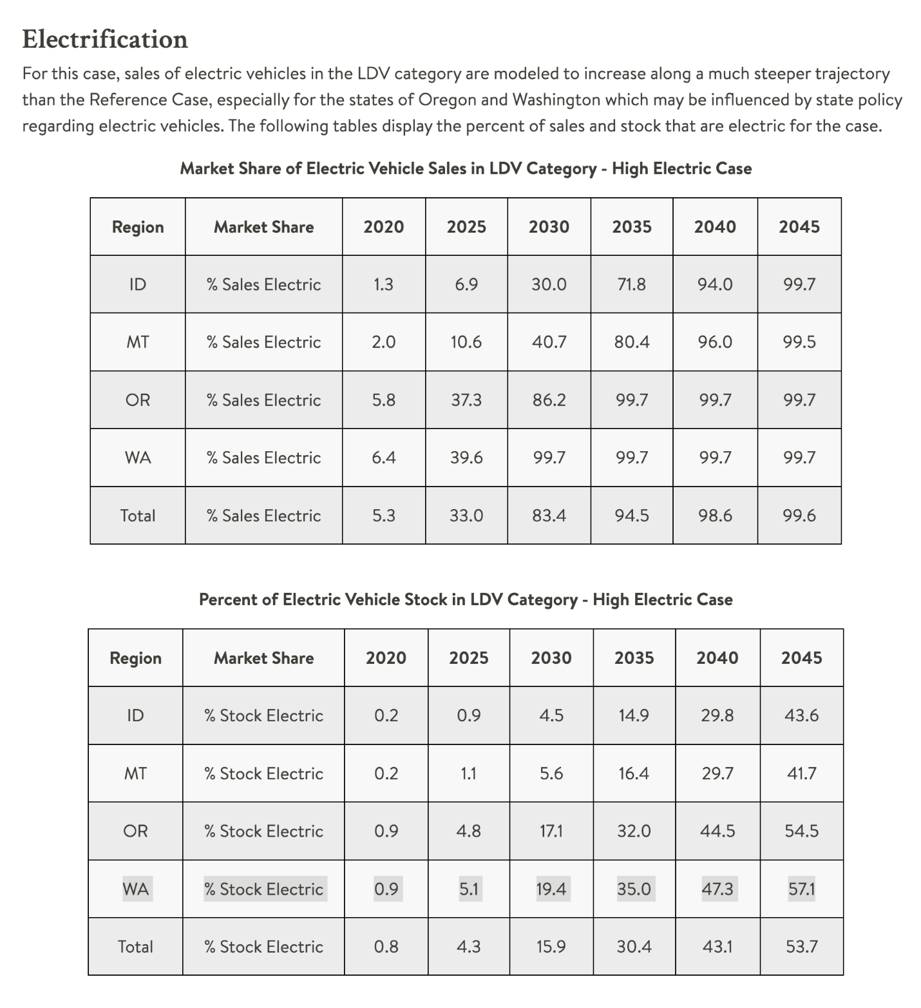
10% EVSE-installed + 10% EV-ready = 20% also exceeds the RCW 19.27.540 requirements for electrical room size. EV-capable parking spaces are considered in the required electrical room size, but not installed electrical service and electrical system requirements.
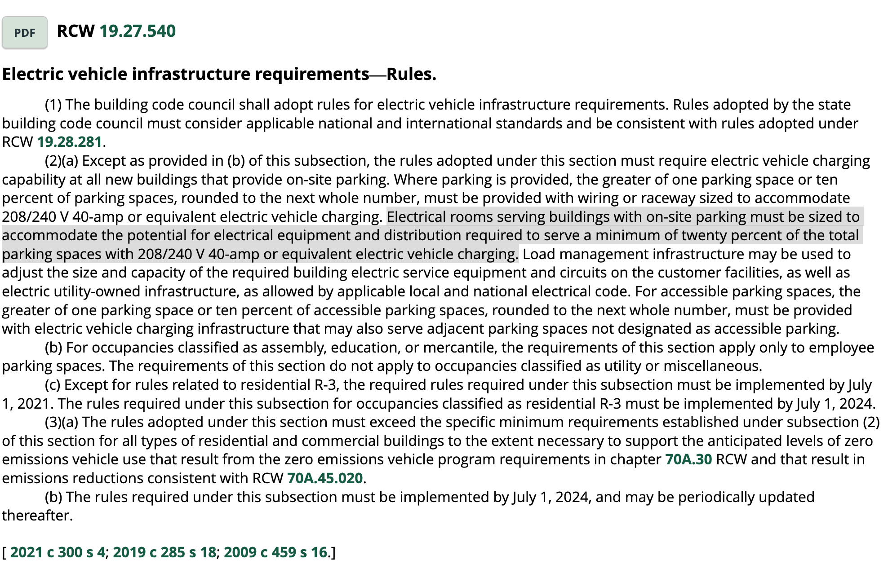

These amendments argue a 2025 / 2030 / 2045 mix for EV / EV-ready / EV-capable of:
10% / 10% / 40% from current 10% / 25% / 10%.

The sensitivity chart below visualizes the base case vs. proposed case (EV-required vs. EV-ready vs. EV-capable). Actual costs can be applied to this simple model for first-cost comparisons.
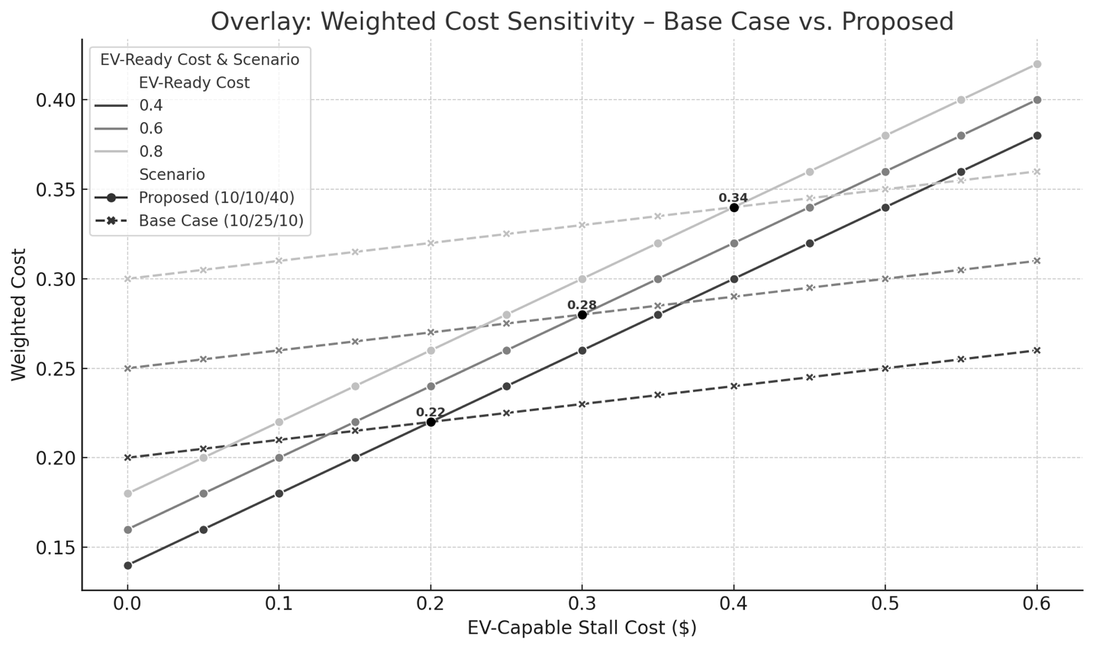
For example:
EV-required = $1.00 cost (normalized)
EV-ready = $0.80, $0.60, or $0.40 cost (relative)
EV-capable = $0.00 to $0.60 cost (relative)

The intersections are the 'break even' costs to the existing base case (10/25/10). Real cost data should be requested from developers to populate the model.

